**Tasks**

The visualization, titled "Unauthorized Immigrant % of Labor Force in Each State" is designed to support several comparative and informative tasks:

**Industry Comparison:** It facilitates a comparison of how frequently different industries appear as having the largest percentage of unauthorized immigrants across states, illustrating the varying impact of unauthorized immigration on industry sectors.

**Highlight Predominant Industries:** By tallying the occurrences of each industry across states, the visualization identifies industries most affected by unauthorized immigration, spotlighting sectors like construction and agriculture.

**Quantitative Insight:** The bar chart quantitatively conveys the count of states where each industry is most impacted by unauthorized workers, providing a clear numeric understanding of the issue's industry-specific distribution.

**Pattern Recognition:** Viewers can recognize patterns in the prevalence of unauthorized immigration across industries, potentially guiding policy focus or public attention to the most affected sectors.

This visualization equips viewers with a clearer understanding of the relationship between unauthorized immigration and specific industries, facilitating informed discourse on labor and immigration policies by emphasizing the industries most influenced by unauthorized workers.

**Data**

Same dataset as the first picture.

**Design process**

I decided to draw a bar chart showing Unauthorized Immigrant % of Labor Force in Each State

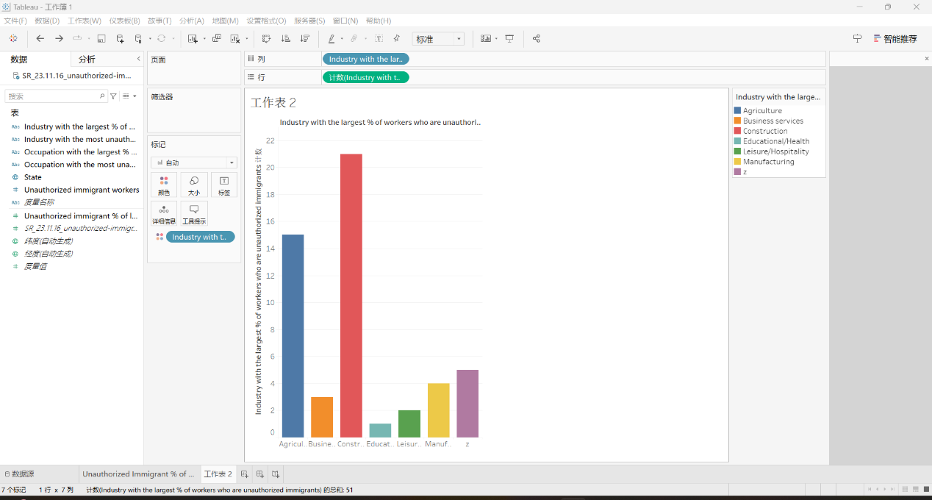

Originally, I decided to show the difference of the industries with the highest percentage of illegal immigrants the industries with the highest absolute numbers (actually they are not same for each state). But coincidentally the total counts for each industry are the same, so I gave up that picture.

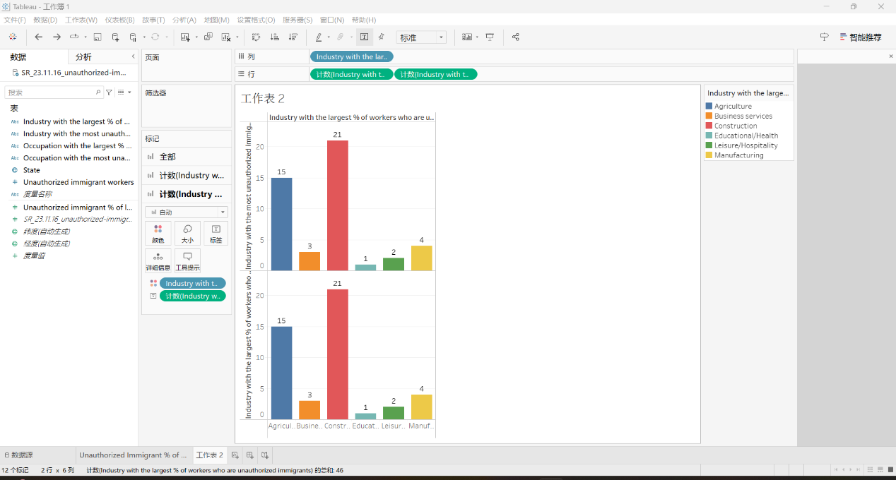

By excluding the unknow industry z and adding the title and labels of the picture, I got the final version of my picture.

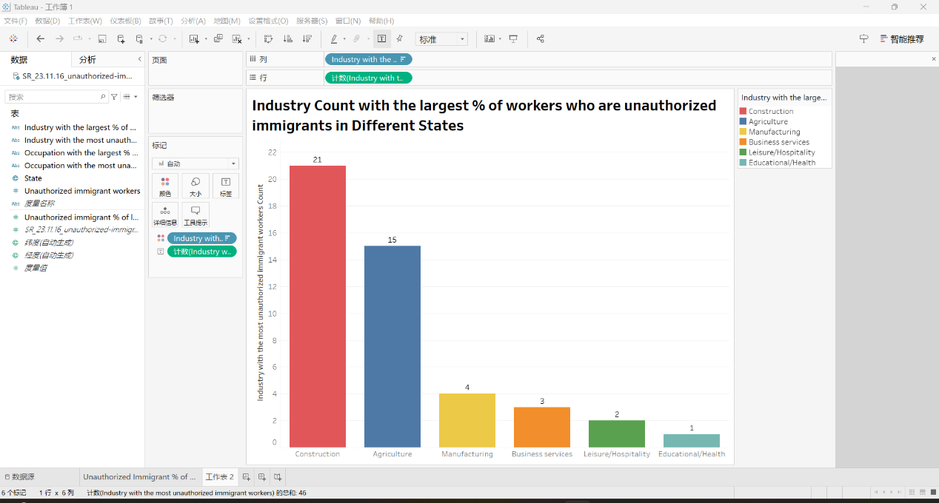

**Qualitative self-evaluation**

**Evaluation:** My design effectively communicates the yearly change in encounter types, using a clear, informative line chart. This approach aligns with the principle of clarity and precision, allowing viewers to easily compare trends over time.

**Effectiveness:** The visualization successfully highlights the increasing trend of Apprehensions and Inadmissibles, while showing the fluctuation in Expulsions. This direct representation of data over time ensures that the message is accurately conveyed, adhering to the principle of showing data accurately.

**Improvement Areas:** Enhancing the chart with interactive elements for deeper exploration and ensuring color choices are accessible to all viewers could further improve its effectiveness. This would align with principles of considering audience needs and engaging viewers more interactively.

**Class Principles Connection:** Reflecting on Tufte’s principles, my design prioritizes data integrity and efficient use of visual elements. However, incorporating feedback and iterating on design elements like interactivity and accessibility could enhance the visualization's overall impact.